Summer 2023: CS5710 – Machine Learning In-Class Programming Assignment-1

Mallika Mamidi (700746126)

1. **A)**.Using NumPy create a random vector of size 15 having only Integers in the range 1-20. 1. Reshape the array to 3 by 5 2. Print array shape. 3. Replace the max in each row by 0

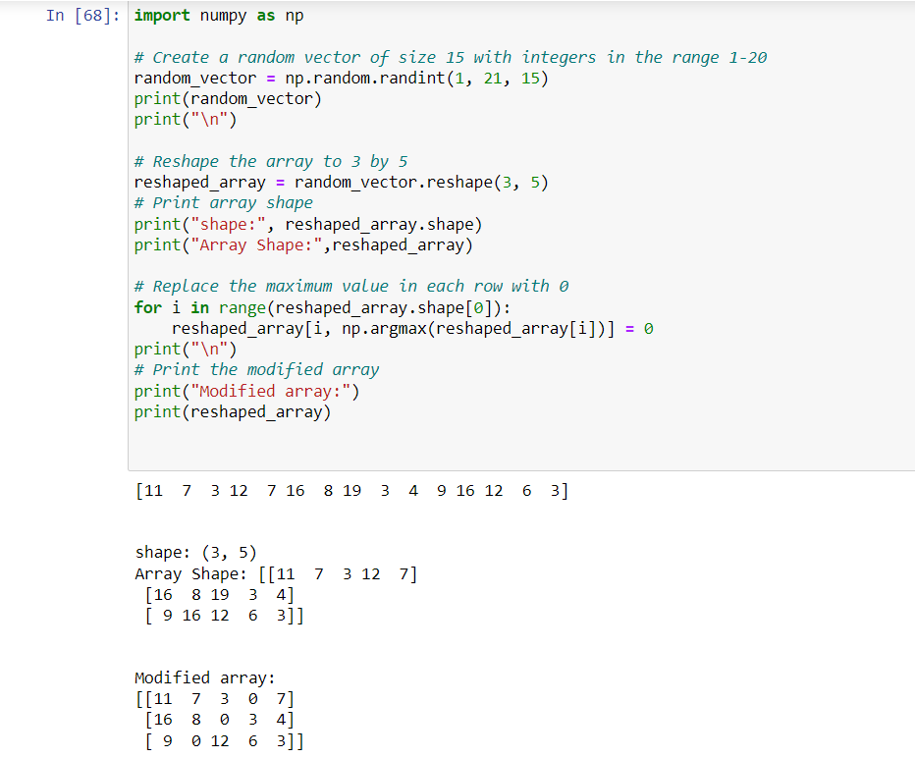

Create a 2-dimensional array of size 4 x 3 (composed of 4-byte integer elements), also print the shape, type and data type of the array.

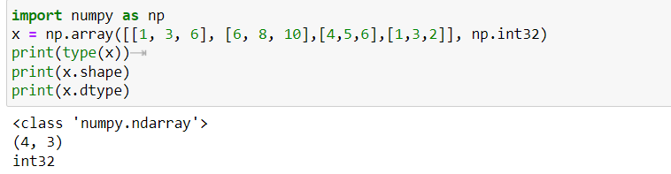

**B**. Write a program to compute the eigenvalues and right eigenvectors of a given square array given below: [[ 3 -2] [ 1 0]] 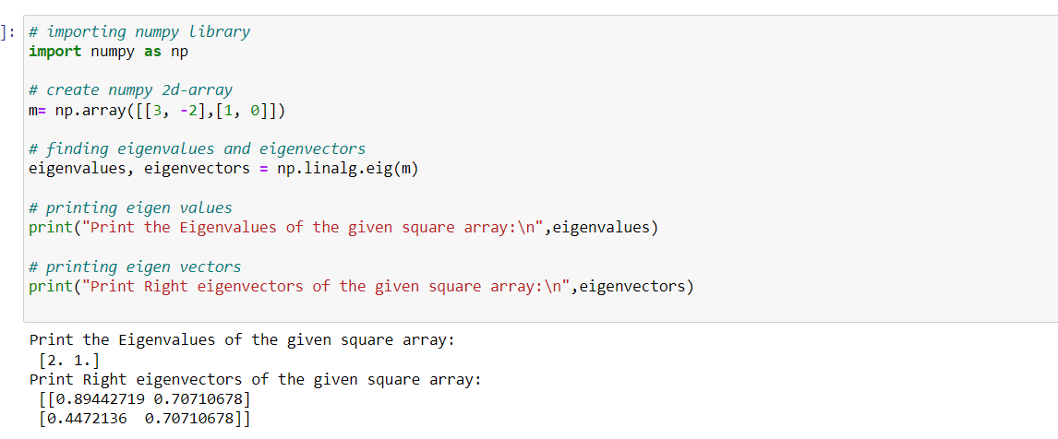

**C**. Compute the sum of the diagonal element of a given array. [[0 1 2] [3 4 5]]

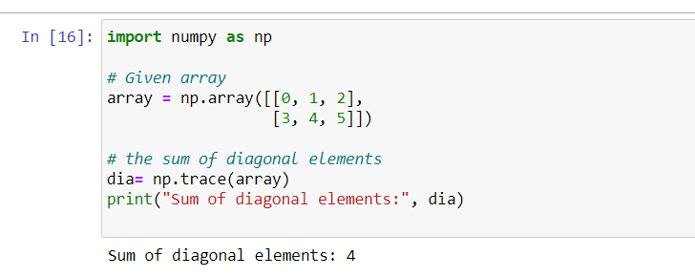

**D**. Write a NumPy program to create a new shape to an array without changing its data. Reshape 3x2: [[1 2] [3 4] [5 6]] Reshape 2x3: [[1 2 3] [4 5 6]]

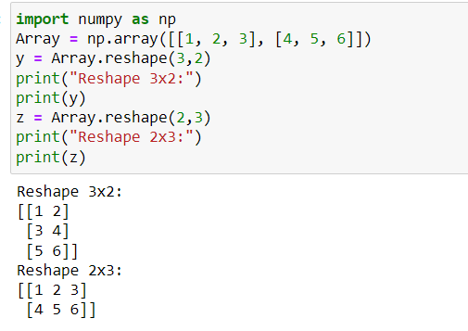

**2**. Write a Python programming to create a below chart of the popularity of programming Languages. 2. Sample data: Programming languages: Java, Python, PHP, JavaScript, C#, C++ Popularity: 22.2, 17.6, 8.8, 8, 7.7, 6.7

